***Creation of IBM Node Red service***

|  |  |
| --- | --- |
| Team ID | PNT2022TMID52668 |
| Project Name | Smart Waste Management System for Metropolitan Cities |

**Screenshots of IBM Node Red :**

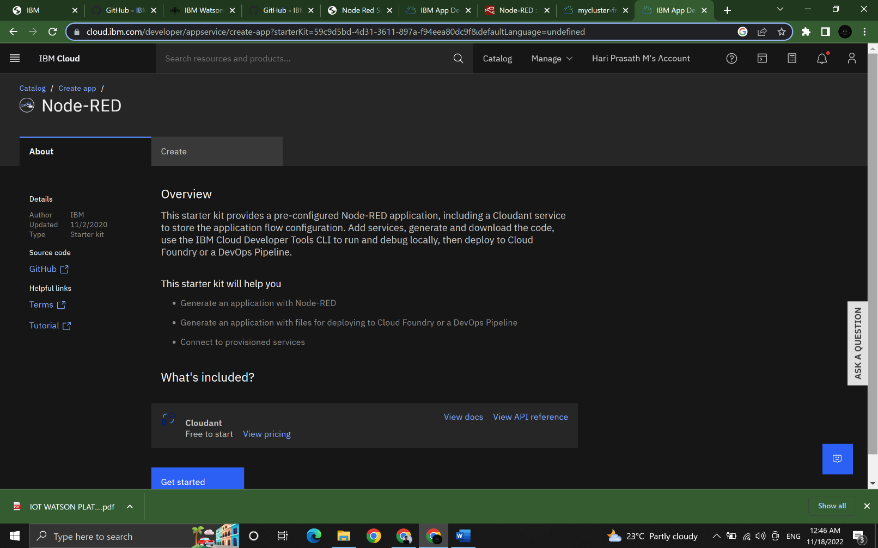**Step 1:** Login into IBM CLOUD account and search Node-RED app

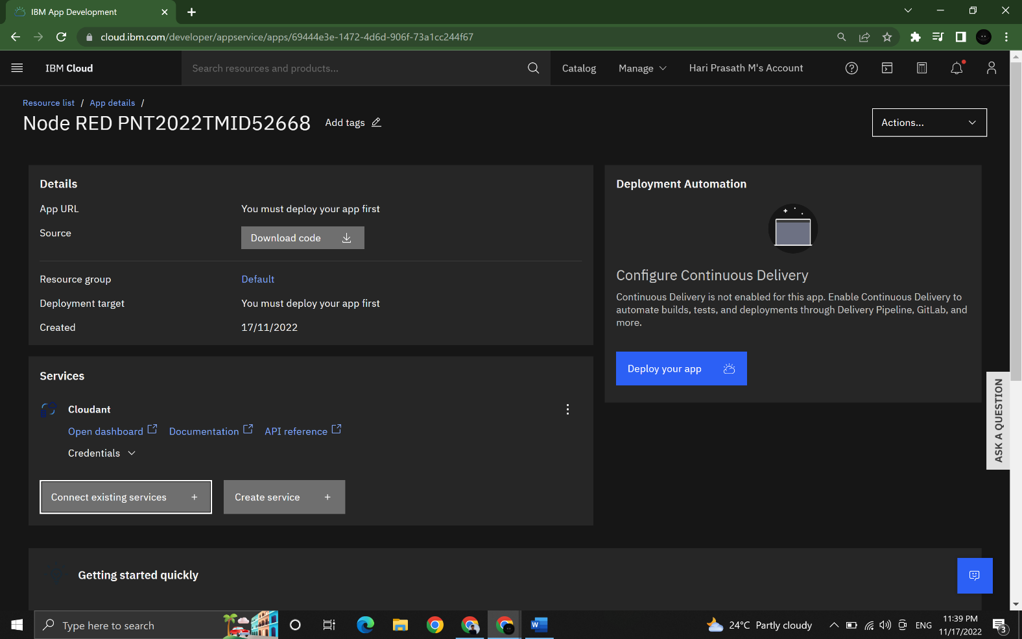**Step 2:** Enter the project details and click on create and deploy the app

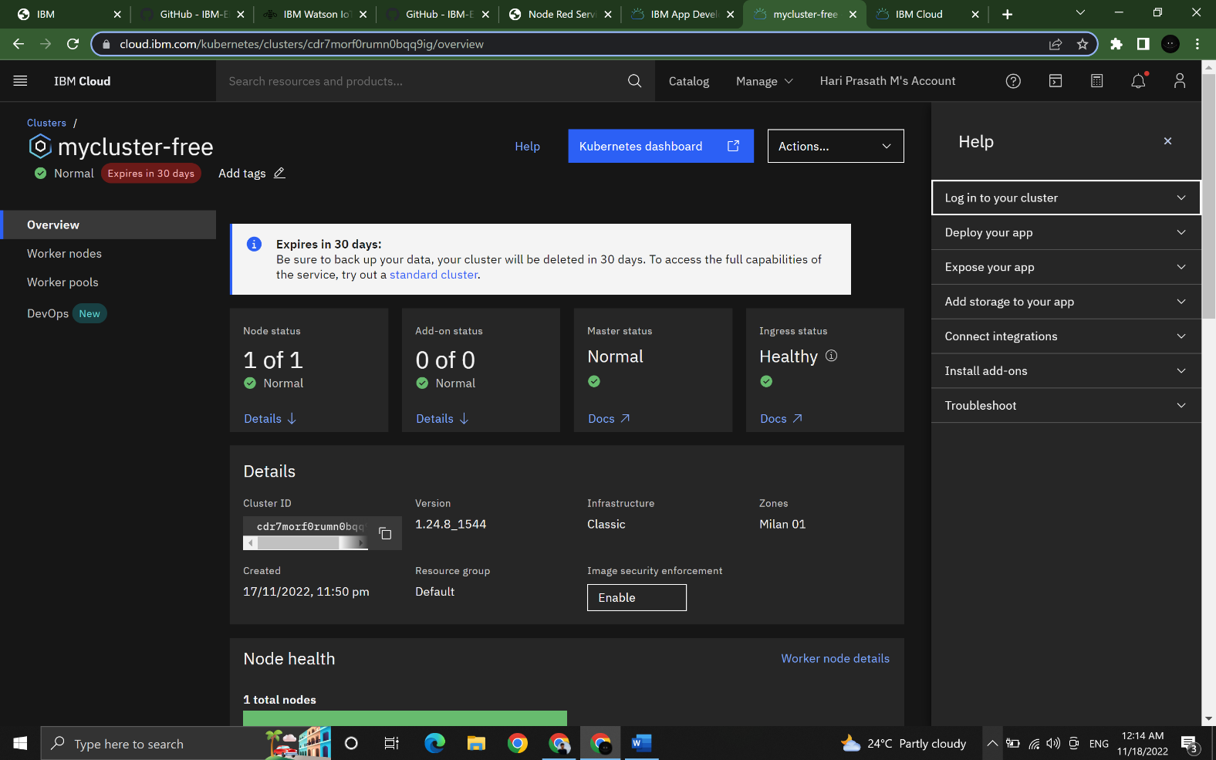

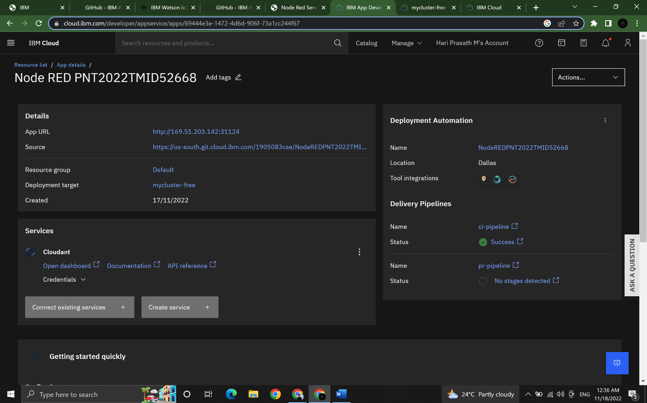**Step3:** Wait till the Node RED pipeline created sucessfully

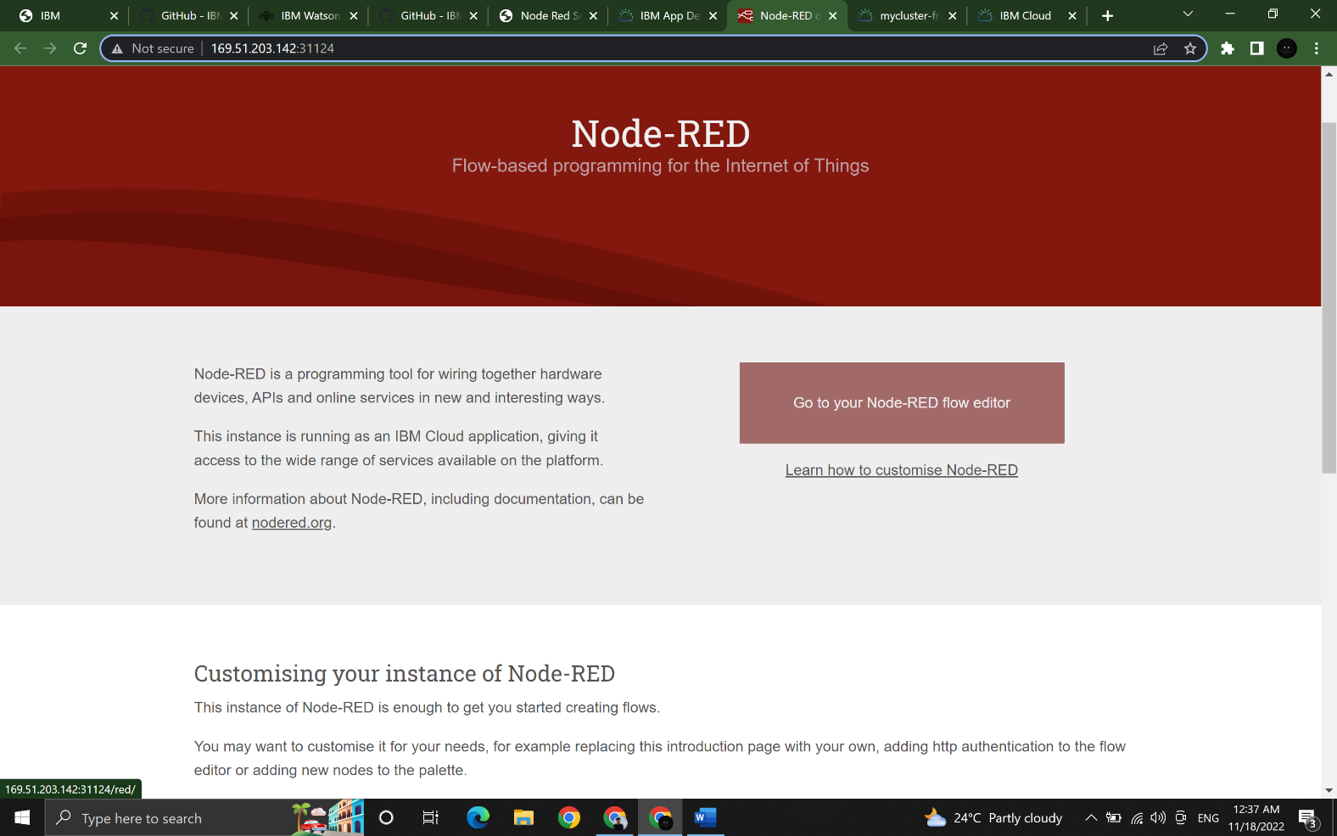**Step 4:** Finally, Node-RED platform is successfully created

